COLOR THEORY INFORMATION SHEET
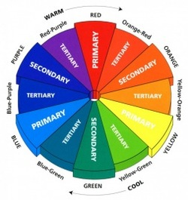
Color Theory Definitions:

Basics of the Color Wheel

Hue Color and hue are synonymous and can be used interchangeably. Red, yellow and blue are the primary colors. Green, orange and violet are the secondary colors and tertiary colors are a mixture of two secondary colors.

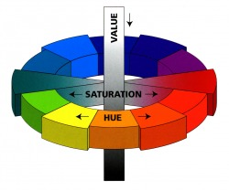
Saturation
The intensity of a color is described as saturation. Saturation is determined by how little or how much gray a color contains. In its purest form, a hue is at maximum saturation; these are colors that are not “grayed.” They are described as: clear, pure, brilliant, bright, rich, bold, vivid and/or true. The grayer or more neutral a color is, the less its saturation. Less saturated colors are described as soft, muted, subtle, toned-down, misty, dull or dusty.

Value

The lightness or darkness of a color is called its value.
Lightened values are tints, darkened values are shades and medium value colors are described as midtones.
The perception of a color is affected greatly by its value or saturation; in planning a color combination, value and saturation are as important as the hue. For example, in the red family, a darkened value of burgundy gives more power than a lighter value of rose pink. A vividly saturated turquoise is more exciting than a pale grayed aqua.

Primary Colors
Primary colors refer to Red, Blue and Yellow. These three colors are the building blocks of the color wheel. From these three colors comes every other color that is on the color wheel, and cannot be made by combining any other colors. Primary colors are known for their vibrancy, and if you think about it, many types of design can be seen utilizing these colors to draw attention to themselves.

Secondary Colors
Secondary colors refer to Green, Orange, and Violet (purple). These three colors are located in between your primaries. This illustrates how in fact your secondary colors are created (ex. green is found in between yellow and blue, the two colors that comprise the makeup of green). These colors usually do not have the same vibrancy that are inherent in the primary colors.
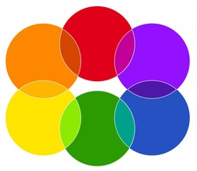

Tertiary Colors
The tertiary colors are found between the primary and secondary colors. Again, they are found in between the colors that are used to create and define them.

Monotone
The use of a single neutral color describes a monotone scheme. This includes light to medium grays, beiges, taupes and off-whites that will impart a calm, quiet quality

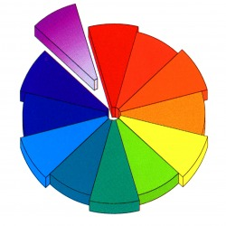
Monochromatics
The use of one color family in various values or intensities is called a monochromatic color scheme.

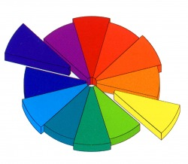
Complementary Colors

Complementary colors mean just that—they are total opposites on the color wheel that enhance each other when used as a pair; they “complete” each other. The red family will appear even redder when contrasted with green, as will orange with blue or yellow with purple. They balance each other as they are opposites, one hue is warm and the other is cool.

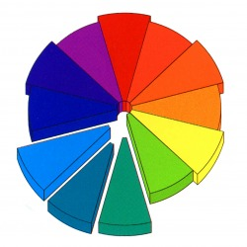
Analogous Colors
Analogous colors are neighboring families on the color wheel. If the combination spans only one-fourth of the color wheel, they are always harmonious as they share the same undertones, for example: blue, blue-green and green.

