NAME ___________________________________________ PD _______ DATE _______________
GRAPHIC DESIGN I • WORKSHEET for Intro to Photoshop CS6 • January 2016
DEFINE SURREALISM:
Research the Internet to find the Definition of Surrealism.
Write that definition here:
________________________________________________________________________________________________________________________________________________________________________________________________________________________________________________
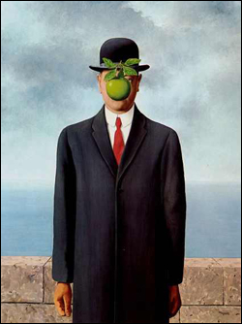
What is the name of this Painting? _________________________________________________
Who is the Artist? ______________________________________________________________
What Year was it Painted? ___________________
How does this Painting meet the definition of Surrealism?
________________________________________________________________________________________________________________________________________________________________________________________________________________________________________________
________________________________________________________________________________________________________________________________________________________________

