2015 **­GD I END OF COURSE EXAM ILLUSTRATOR TOOLS & FUNCTIONS**

**1:  The Name of this Tool is:**

The Selection Tool

**2.  The Name of this Tool is:**

The Text Tool

**3.  The Name of this Tool is:**

The Direct Selection Tool

**4.  The Name of this Tool is:**

The Zoom Tool

**5. 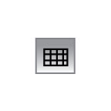 The Name of this Tool is:**

The Rectangular Grid Tool

**6.  The Name of this Tool is:**

The Type on a Path Tool

**7.  The Name of this Tool is:**

The Group Selection Tool

**8.  The Name of this Tool is:**

The Pen Tool

**9. 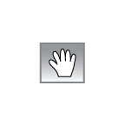 The Name of this Tool is:**

The Hand Tool

**10.  The Name of this Tool is:**

The Rotate Tool

**11. 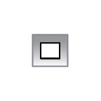 The Name of this Tool is:**

The Rectangle Tool

**12.  The Name of this Tool is:**

The Blob Tool

**13. 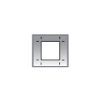 The Name of this Tool is:**

The Art Board Tool

**14.  The Name of this Tool is:**

The Polygon Tool

**15.  The Name of this Tool is:**

The Star Tool

**16.  The Name of this Tool is:**

The Scale Tool

**17.  The Name of this Tool is:**

The Eye Dropper Tool

**18.  The Name of this Tool is:**

The Rounded Rectangle Tool

**19. 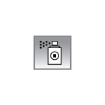 The Name of this Tool is:**

The Symbol Sprayer Tool

**20. 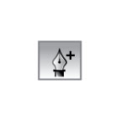 The Name of this Tool is:**

The Add Anchor Point Tool

**21. Which Window / Function would you be using if you were to combine all the parts**

**and then “Unite” them.**

The Pathfinder Tool / Menu

**22. What Function / Procedure is the following an example of ?**

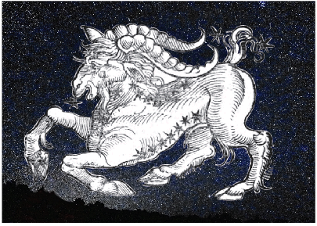 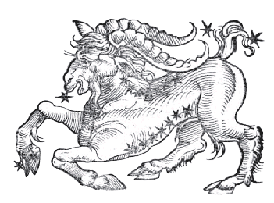

Blob Tool > Clipping Mask

**23. What is the Formula for the Radial Lines**



Select All > Copy & Paste in Front > Rotate

**24. What Function / Procedure is the following an example of ?**

1  2  3  4 

Create a Square > Create a smaller Square   
> Align both Squares Centered > Compound Path / Make

**25. What Function / Procedure is the following an example of ?**

1 2

Create a Circle > Set your Type > Select Type & Copy (Control C)

Click on the Type on a Path Tool on the Circle > Paste

**PHOTOSHOP TOOLS & FUNCTIONS ______________________________________________________**

**26  The Name of this Tool is:** The Move Tool

**27  The Name of this Tool is:** The Dodge Tool

**28  The Name of this Tool is:** The Marquee Tool

**29  The Name of this Tool is:** The Lasso Tool

**30  The Name of this Tool is:** The Magic

**31  The Name of this Tool is:** The Zoom Tool

**32  The Name of this Tool is:** The Eye Dropper Tool

**33  The Name of this Tool is:** The Paint Brush

**34  The Name of this Tool is:** The Blur Tool

**35  The Name of this Tool is:** The Rectangle Shape Tool

**36  The Name of this Tool is:** The Paint Bucket

**37  The Name of this Tool is:** The Pen

**38**  **The Name of this Tool is:** The Eraser Tool

**39**  **The Name of this Tool is:** The Clone Stamp Tool

**40**  **The Name of this Tool is:** The Text / Type Tool

**41**  **The Name of this Tool is:** The Smudge Tool

**42 Which of the following are the correct labels for the “Parts” of this file?**

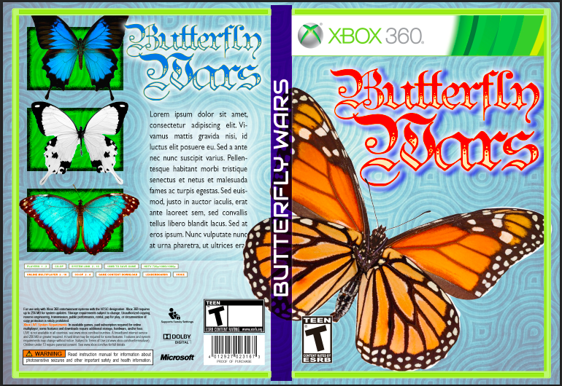

**1 2 3** 1 = Back • 2 = Spine • 3 = Front

**43 Lorem Ipsum is . . .**

Latin Text that can “hold” the place until the actual text is written / supplied, Dummy text of the graphic design, printing and typography industry.

All of the above

**44 The “CD” in the Final Presentation of the Personal CD Project is what kind of file?** TIFF

**45 The Final art of the Personal CD Project was a _________________ made in _________________.**

JPEG / Illustrator

**46 To turn a Layer “ON” or “OFF” you have to Click the “EYE”** TRUE

**47 When we move a Layer Up it puts an image “In Front” of another image.** TRUE

**48 When we want to copy a Layer, we Right-Click on the Layer and choose “Duplicate Layer”** TRUE

**49 The correct process to make an image face the other direction (left to right, or right to left) is:**

Click on the Layer, Go to “Edit” > Chose “Transform” > Choose “Flip Horizontal”

**50 The final action when filling a CD or any Shape with a Picture is . . .**

With the Shape (CD) Selection Active

> Chose the Picture > Right-Click > Choose Layer via Copy