NAME:____________________________________________ PD ________ DATE ___________________

GD II • End of Course Exam Page 1
- This is a picture of what Printer Mark?
A. Margin B. Crop Marks C. Fold D. Bleed
2. 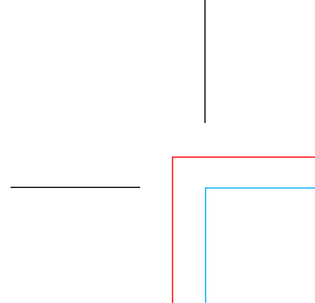 The Red Line in this picture represents what Printer Mark?
A. Margin B. Crop Marks C. Fold D. Bleed

3. The Dashed Line in this picture represents what Printer Mark?
A. Margin B. Crop Marks C. Fold D. Bleed

4. Areas of White Space or just Empty Space around objects and Type on a Layout are called ____________ ?
A. Margin B. Crop Marks C. Fold D. Bleed

5. 11” x 17” represents what Paper Size?
A. Letter B. Tabloid C. Legal D. A-1

6. 8.5” x 11” represents what Paper Size?
A. Letter B. Tabloid C. Legal D. A-1

7. 8.5” x 14” represents what Paper Size?
A. Letter B. Tabloid C. Legal D. A-1

8. What Tool is this?
A. Rectangle Tool B. Rounded Rectangle Tool C. Rectangular Grid Tool D. Mesh Tool

GD II • End of Course Exam Page 2

9. What Tool did we use to make the Calendar Grid?
A. Rectangle Tool B. Rounded Rectangle Tool C. Rectangular Grid Tool D. Mesh Tool

10. What was the Page Size for the Calendar?
A. 11“ x 17” B. 8.5” x 11” C. 8.5” x 14” D. 8” x 8”

11. What is the FLAT (Open / Unfolded) Size of the Calendar?
A. 11“ x 17” B. 8.5” x 11” C. 8.5” x 14” D. 8” x 8”

12. What is the FOLDED Size of the Calendar?
A. 11“ x 17” B. 8.5” x 11” C. 8.5” x 14” D. 8” x 8”

13. What does CMYK stand for?
A. St Lucie School Board B. Red Green Blue
C. Cyan, Magenta, Yellow, Black D. Clams, Mussels, Yams, Kellog’s

14. What is CMYK?
A. 4-Color Printing Process B. The Color settings for images for use on the Web
C. Internet Coordinates D. Clams, Mussels, Yams, Kellog’s

15. What does RGB stand for?
A. St Lucie School Board B. Red Green Blue
C. Cyan, Magenta, Yellow, Black D. Roasted, Green Broccoli

16. What is RGB ?
A. 4-Color Printing Process B. The Color settings for images for use on the Web
C. Internet Coordinates D. Clams, Mussels, Yams, Kellog’s

17. What are the 3 forms of Balance?
A. Rhythm, Movement & Proportion B. Principle, Radial & Scale
C. Right, Left & Center D. Symmetrical, Asymmetrical & Radial

Continued on next Page
GD II • End of Course Exam Page 3

18. What is the order of these Balance Examples?
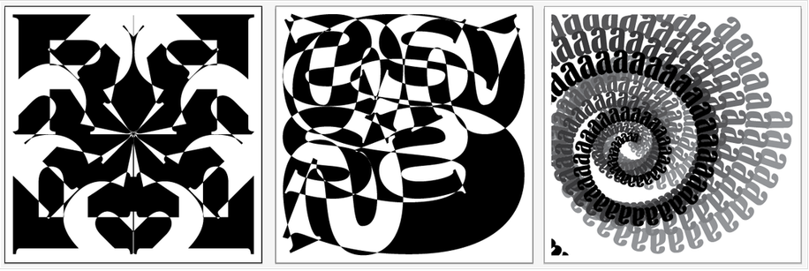
A. Radial, Asymmetrical & Symmetrical B. Symmetrical, Asymmetrical & Radial
C. Asymmetrical, Radial & Symmetrical D. Symmetrical, Radial & Asymmetrical

19. Which Principle of Design are these examples of?
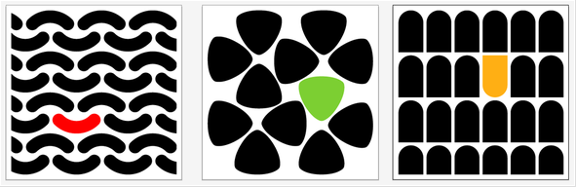
A. Emphasis B. Rhythm C. Balance D. Unity

20. What does this Diagram signify?
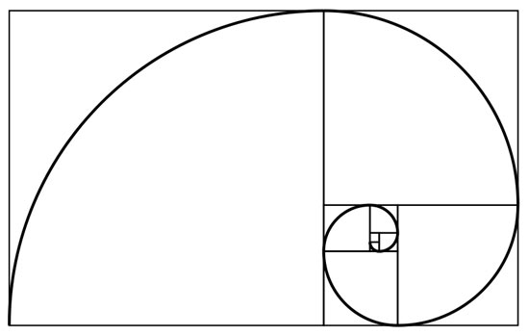
A. Margins B. Crop Marks C. Rule of Thirds D. Perfect Proportion & Scale

Continued on next Page
GD II • End of Course Exam Page 4
21. 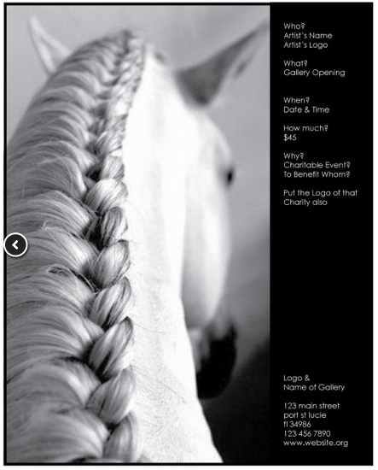 Which of the following is this image an example of?
A. Right Side Page Placement B. Left Side Page Placement
C. Landscape Ad Layout D. 4-Color Process

22. 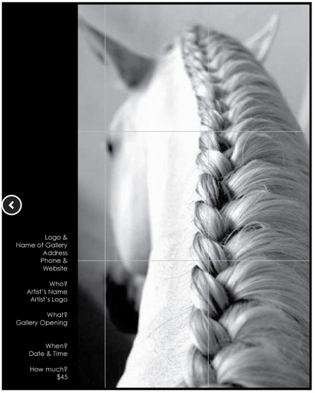 Which of the following is this image an example of?
A. Right Side Page Placement B. Left Side Page Placement
C. Landscape Ad Layout D. 4-Color Process

23. 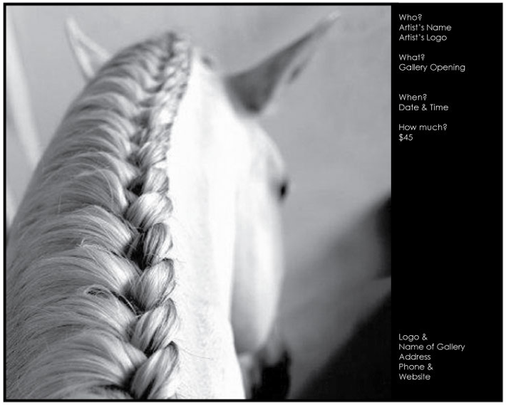 Which of the following is this image an example of?
A. Right Side Page Placement B. Left Side Page Placement
C. Landscape Ad Layout D. 4-Color Process

Continued on next Page
GD II • End of Course Exam Page 5

24. 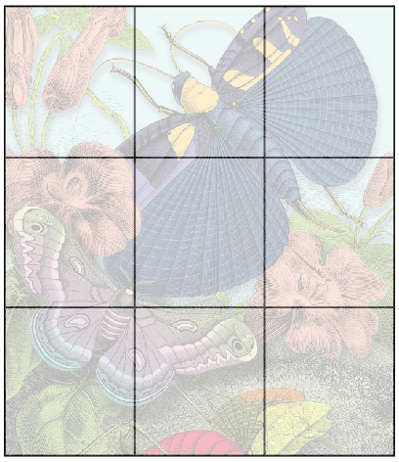 Which of the following choices is the Grid an Example of?

A. Margins B. Crop Marks C. Rule of Thirds D. Perfect Proportion & Scale

25. What is the size of the Proportion & Scale Ads?
A. 11“ x 17” B. 8.5” x 11” C. 8.5” x 14” D. 8” x 10”
26. Which of the following are Principles of Design?
A) Emphasis, Shape, Color, Proportion & Scale, Line & Rhythm
B) Line, Size, Color, Direction, Shape, Value, Pattern, Texture and Space
C) Emphasis, Balance, Proportion & Scale and Rhythm
D) Dance, Music, Balance, Free weights and Gymnastics
27 Which of the following are the Elements of Design
A) Emphasis, Shape, Color, Proportion & Scale, Line & Rhythm
B) Line, Size, Color, Direction, Shape, Value, Pattern, Texture and Space
C) Emphasis, Balance, Proportion & Scale and Rhythm
D) Dance, Music, Balance, Free weights and Gymnastics
28 The white space around areas of color, type and shapes is called a
A) Kerning, Tracking or Letter Spacing C) Leading or Line Spacing
B) Margin D) Bleed
29 Adjusting the space between letters is called
A) Kerning, Tracking or Letter Spacing C) Leading or Line Spacing
B) Margin D) Bleed
30 Adjusting the space from one line of type to the line above or below it is called
A) Kerning, Tracking or Letter Spacing C) Leading or Line Spacing
B) Margin D) Bleed
GD II • End of Course Exam Page 6
31 The area of color that goes beyond the page size is called
A) Kerning, Tracking or Letter Spacing B) Margin
C) Leading or Line Spacing D) Bleed

32 The Right Angle Strokes at the corners of the Page Size are called
A) Fold B) Type Style C) Page Size D) Crop Marks
33 The Light Blue Dashed Line across an area of a Page designates it’s a
A) Fold B) Type Style C) Page Size D) Crop Marks
34 The Rectangular shape with Crop Marks at the corners is the
A) Fold B) Type Style C) Page Size D) Crop Marks
35 The best way to describe a Serif is
A) A small line used to finish off a main stroke of a letter, as at the top and bottom of M.
B) A guy who usually has a gun and runs the town while riding a horse
C) A symbol that looks like what the word Hash Tag is
D) Found only in Adobe Illustrator
36 The best way to describe a Sans Serif is
A) A small line used to finish off a main stroke of a letter, as at the top and bottom of M.
B) A typeface that does not have the small lines at the bottom and tops of letters.
C) A symbol that looks like what the word Hash Tag is
D) Found only in Adobe Photoshop

37 Which of the following best describes the Principle of Design: Rhythm
A) Making some element of the design a different size or different color or go in a different direction
B) It is Symmetrical, Asymmetrical or Radial
C) Pattern, Repetition, Movement, Energy and Flow
D) It is perfectly proportioned to other parts of the design, Rule of Thirds

38 Which of the following best describes the Principle of Design: Emphasis
A) Making some element of the design a different size or different color or go in a different direction, also Grabs Attention, also Focus of Attention B) It is Symmetrical, Asymmetrical or Radial
C) Pattern, Repetition, Movement, Energy and Flow
D) It is perfectly proportioned to other parts of the design, Rule of Thirds
GD II • End of Course Exam Page 7
39 Which of the following best describes the Principle of Design: Proportion & Scale
A) Making some element of the design a different size or different color or go in a different direction, also Grabs Attention, also Focus of Attention
B) It is Symmetrical, Asymmetrical or Radial
C) Pattern, Repetition, Movement, Energy and Flow
D) It is perfectly proportioned to other parts of the design, Rule of Thirds

40 Which of the following best describes the Principle of Design: Balance
A) Making some element of the design a different size or different color or go in a different direction, also Grabs Attention, also Focus of Attention
B) It is Symmetrical, Asymmetrical or Radial
C) Pattern, Repetition, Movement, Energy and Flow
D) It is perfectly proportioned to other parts of the design, Rule of Thirds

41 Which of the following is the correct way to Name and / Or Save a Folder?
A) We don’t have a Folder Saving Format
B) 562 Server > Pictures > Project Folder > Folders for Specific Parts of the Projects
C) 562 Server > Documents > Project Folder > Folders for Specific Parts of the Projects
D) 562 Server > GDII – 3rd QTR > Project Folder > Folders for Specific Parts of the Projects

42 Which of the following is the correct way to Name a File?
A) We don’t have a File Naming Format
B) Untitled75.whatever
C) (Your First) NameProjectNamePdX.(.psd, .jpg, .ai, .gif, .pdf)
D) 562 Server > GDII – 3rd QTR > Project Folder > Folders for Specific Parts of the Projects
43 Which of the following is the appropriate program to design with Type?
A) Adobe Illustrator = Vector B) Photoshop = Pixels
C) MicroSoft Word D) Paint

44 Which of the following is the appropriate program to work with Images
A) Adobe Illustrator = Vector B) Photoshop = Pixels
C) MicroSoft Word D) Paint

Continued on next Page
GD II • End of Course Exam Page 8
45 Which of the following is the best type style for Body Copy or Text?
A) Large, bold, maybe ALL CAPS, 18 – 24 point size Font
B) A regular, easy to read font, 10 – 12 point size
C) A small, 6 - 8 point size, italic font
D) A DaFont Style that we make in Photoshop
46 Which of the following is the best type style for Headlines in a document?
A) Large, bold, maybe ALL CAPS, 18 – 24 point size Font
B) A regular, easy to read font, 10 – 12 point size
C) A small, 6 - 8 point size, italic font
D) A DaFont Style that we make in Photoshop
47 Which of the following is the best type style for a Caption for a picture in a document?
A) Large, bold, maybe ALL CAPS, 18 – 24 point size Font
B) A regular, easy to read font, 10 – 12 point size
C) A small, 6 - 8 point size, italic font
D) A DaFont Style that we make in Photoshop
48 Which of the following is the best typeface for Presentation to a Client before Final Production?
A) Large, bold, maybe ALL CAPS, 18 – 24 point size Font
B) A regular, easy to read font, 10 – 12 point size
C) A small, 6 - 8 point size, italic font
D) A DaFont Style that we make in Photoshop

49 The Font (1)____________________ consists of (2)__________________________.
A) (1) Brotherhood (2) Regular, Italic, Bold, Bold Italic
B) (1) Neighborhood (2) Regular, Italic, Bold, Bold Italic
C) (1) Step – Children (2) Regular, Italic, Bold, Bold Italic
D) (1) Family (2) Regular, Italic, Bold, Bold Italic

50 What is the terminology used to describe the Process of Printing:
A) RGB B) Monotone C) Lab Color D) CMYK

