GD II • End of Course Exam Page 1
- This is a picture of what Printer Mark? Crop Marks
- 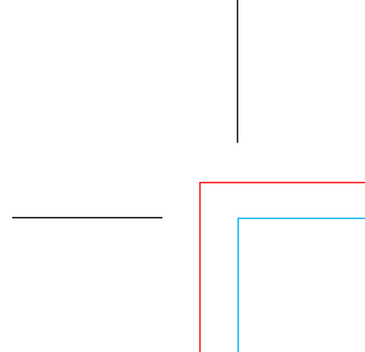 The Red Line in this picture represents what Printer Mark? Bleed

3. The Dashed Line in this picture represents what Printer Mark? Fold

4. Areas of White Space or just Empty Space around objects and Type on a Layout are called: Margin

5. 11” x 17” represents what Paper Size? Tabloid

6. 8.5” x 11” represents what Paper Size? Letter

7. 8.5” x 14” represents what Paper Size? Legal

8. What Tool is this? Rectangular Grid Tool
9. What Tool did we use to make the Calendar Grid? Rectangular Grid Tool

10. What was the Page Size for the Calendar? 11“ x 17”

11. What is the FLAT (Open / Unfolded) Size of the Calendar? 11“ x 17”

12. What is the FOLDED Size of the Calendar? 8.5” x 11”

13. What does CMYK stand for? Cyan, Magenta, Yellow, Black

14. What is CMYK? 4-Color Printing Process

15. What does RGB stand for? Red Green Blue

16. What is RGB ? The Color settings for images for use on the Web

17. What are the 3 forms of Balance? Symmetrical, Asymmetrical & Radial

18. What is the order of these Balance Examples? Symmetrical, Asymmetrical & Radial
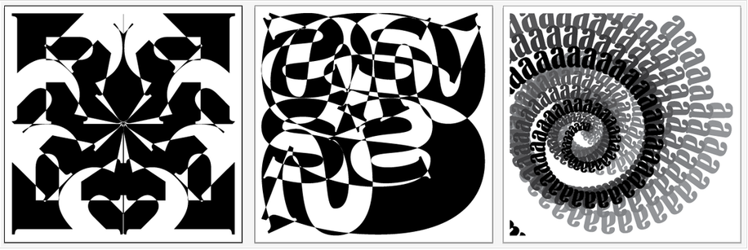

19. Which Principle of Design are these examples of? Emphasis
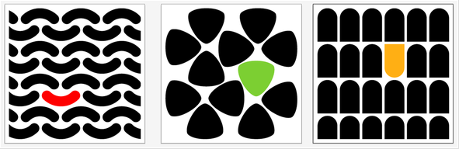

20. What does this Diagram signify? Fibinacci’s Ratio, The Golden Ratio
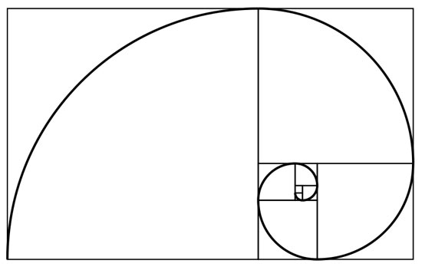
21. 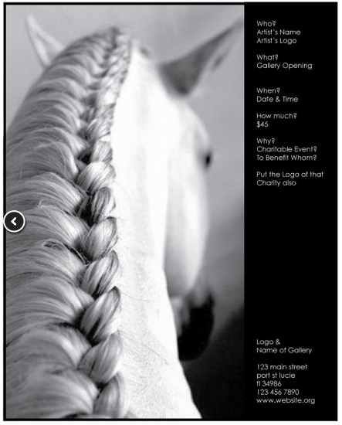
Which of the following is this image an example of? Left Side Page Placement
22. 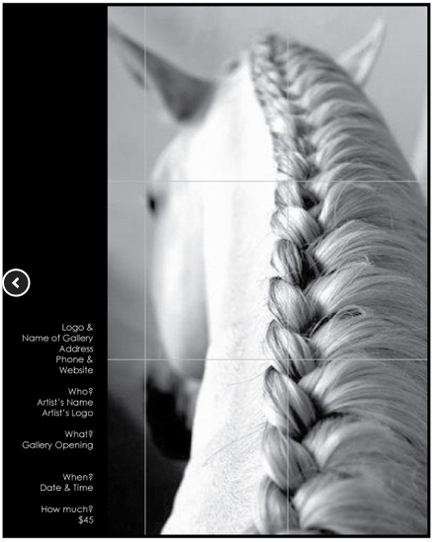
Which of the following is this image an example of? Right Side Page Placement

23. 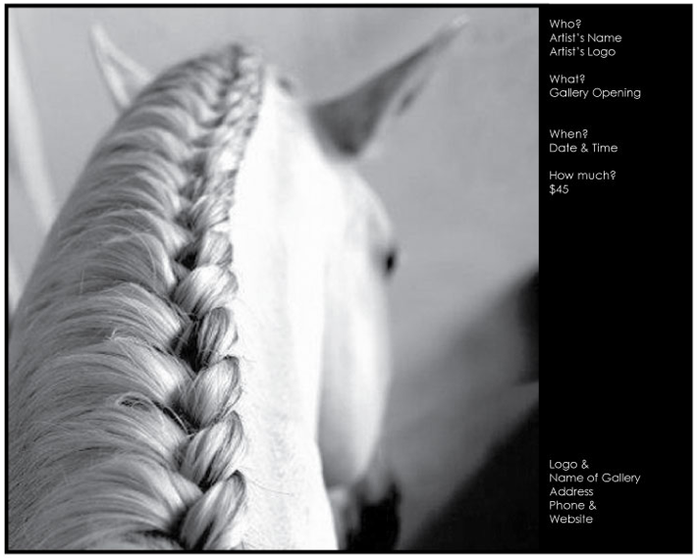
Which of the following is this image an example of? Landscape Ad Layout

24. 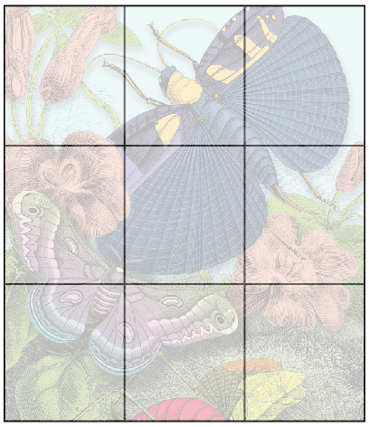
Which of the following choices is the Grid an Example of? Rule of Thirds
25. What is the size of the Proportion & Scale Ads? 8.5” x 11”
26. Which of the following are Principles of Design?
Emphasis, Balance, Proportion & Scale and Rhythm
27 Which of the following are the Elements of Design
Line, Size, Color, Direction, Shape, Value, Pattern, Texture and Space

28 The white space around areas of color, type and shapes is called a Margin
29 Adjusting the space between letters is called Kerning, Tracking or Letter Spacing
30 Adjusting the space from one line of type to the line above or below it is called
Leading or Line Spacing
31 The area of color that goes beyond the page size is called Bleed

32 The Right Angle Strokes at the corners of the Page Size are called Crop Marks
33 The Light Blue Dashed Line across an area of a Page designates it’s a Fold
34 The Rectangular shape with Crop Marks at the corners is the Page Size
35 The best way to describe a Serif is
A small line used to finish off a main stroke of a letter, as at the top and bottom of M

36 The best way to describe a Sans Serif is
A typeface that does not have the small lines at the bottom and tops of letters.

37 Which of the following best describes the Principle of Design: Rhythm
Pattern, Repetition, Movement, Energy and Flow

38 Which of the following best describes the Principle of Design: Emphasis
Making some element of the design a different size or different color or go in a different direction, also Grabs Attention, also Focus of Attention.
39 Which of the following best describes the Principle of Design: Proportion & Scale
It is perfectly proportioned to other parts of the design, Rule of Thirds

40 Which of the following best describes the Principle of Design: Balance
It is Symmetrical, Asymmetrical or Radial

41 Which of the following is the correct way to Name and / Or Save a Folder?
562 Server > GDII – 4th QTR > Project Folder > Folders for Specific Parts of the Projects

42 Which of the following is the correct way to Name a File?
(Your First) NameProjectNamePdX.(.psd, .jpg, .ai, .gif, .pdf, .tif)
43 Which of the following is the appropriate program to design with Type?
Adobe Illustrator = Vector

44 Which of the following is the appropriate program to work with Images
Photoshop = Pixels
45 Which of the following is the best type style for Body Copy or Text?
A regular, easy to read font, 10 – 12 point size

46 Which of the following is the best type style for Headlines in a document?
Large, bold, maybe ALL CAPS, 18 – 24 point size Font

47 Which of the following is the best type style for a Caption for a picture in a document?
A small, 6 - 8 point size, italic font
48 Which of the following is the best typeface for Presentation to a Client before Final Production?
A DaFont Style that we make in Photoshop

49 The Font (1)____________________ consists of (2)__________________________.
(1) Family (2) Regular, Italic, Bold, Bold Italic

50 What is the terminology used to describe the Process of Printing: CMYK

