GRAPHIC DESIGN 1 • VIDEO GAME PACKAGING DESIGN • FINAL ART DIRECTIONS
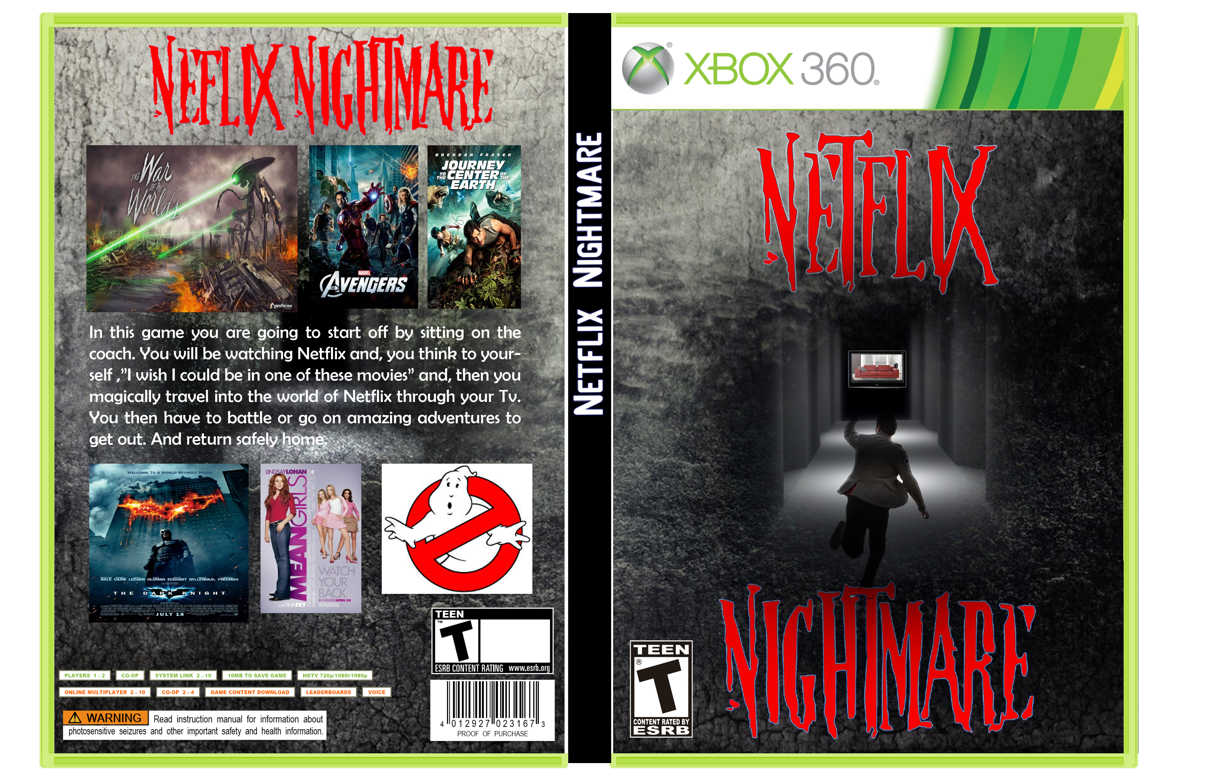
Game Packaging Design by Jenessa Funes • Grade 9 • Graphic Design 1 • Period 7
The above Video game Package is a good example of how you should plan the final presentation of your packaging project. Here are the points to include:
FIRST & FOREMOST: The packaging is in front of all the other parts
FRONT:
□ Title: DaFont.com Tutorial Typeface
□ A Background image
□ A central figure / character in your game or a central visual
SPINE:
□ The Title should be “pointing” UP or written going “UPWARD” on the spine
□ The spine should be clearly marked in some way.
BACK:
□ The (DaFont) Title needs to be straight: Reading from left to right
□ A Background image
□ At LEAST 2 - preferably 3 - “scenes” from your game.
□ Your Description in a Body Text typeface.

GRAPHIC DESIGN 1 • VIDEO GAME PACKAGING DESIGN • Final Art Directions Continued

□ Save the File 1) as a .psd: :   (Your First) NameVideoGameDesignPdX.psd
□ Save that file again as a .jpg by choosing the “Save for Web & Devices” option under “File”
□ Make sure the file is named correctly:   (Your First) NameVideoGameDesignPdX.jpg
Make sure you name it and save it so that you will know where and how to find it!

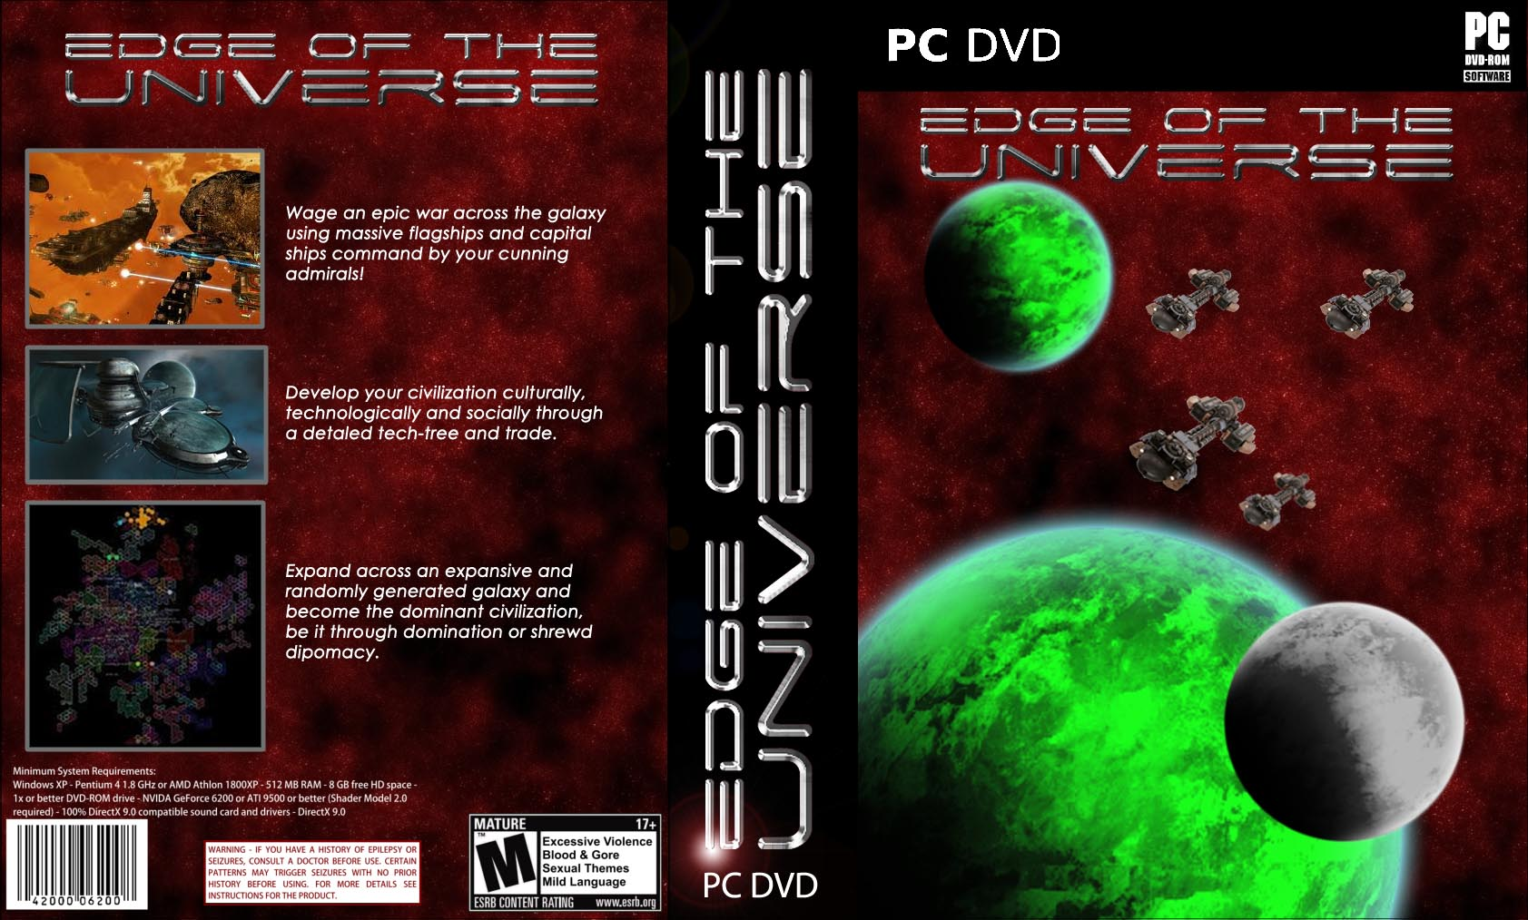
The above piece is a Video Game Design by Sebastian Quick • Grade 12 • Graphic Design 1 • Period 5

Here is the RUBRIC for your Video Game:
You’ll notice that I have color-coded each of the sections that you might find it easier to follow.
Let me know if this is helpful.
CONTENTS OF THE STEP | 100 | 90 | 80 | 70 | 60
The Packaging is in front
FRONT:  Title . . . Designed using the  DaFont.com Tutorial Typeface | Student has used  Innovative design elements | Student has included design elements | Student has met the assigned requirements | Student has not met the assigned requirements | Student has not done the work
FRONT: A Background image
FRONT: A central character in your game or a central visual
SPINE:  The Title is written going “UP” | Student has used  Innovative design elements | Student has included design elements | Student has met the assigned requirements | Student has not met the assigned requirements | Student has not done the work
SPINE: It is clear that this the Spine of the Box
BACK:  The Title is on the back in the same style that it is on the Front | Student has used  Innovative design elements | Student has included design elements | Student has met the assigned requirements | Student has not met the assigned requirements | Student has not done the work
BACK: A Background image
BACK:
2 – 3 “Scenes” from your Game
BACK: Description in an
easy-to-read (legible) typeface
FINAL ART: Saved the File as a PSD in your 4th Quarter Folder | Student has used  Innovative design elements | Student has included design elements | Student has met the assigned requirements | Student has not met the assigned requirements | Student has not done the work
FINAL ART : Used the
“Save for Web & Devices” option to save the file as a JPEG
FINAL ART :
Put that in the JPEG Folder
FINAL ART:
Named the File correctly:
VideoGameDesignPdX.psd
Let Babkie know if this
color-coding was helpful

